**A Project Report on**

**PRIYANKA SPICE FACTORY**

**Submitted to**

**Edubridge Learning Private Limited, Chennai**

**In partial fulfillment of the requirements for the award of**

**Course in**

**SOFTWARE TESTING**

**By**

**Ms. Priyanka P**

**(Center-Chennai, Batch code-7688)**

**Under Guidance of**

**Mrs. Mohana Priya B.E M.E(Ph.D.)**

**(center Trainer)**

**Course for Software Testing**

**Edubridge Learning Private Limited, Chennai**

**2022-2023**

**EDUBRIDGE LEARNING COURSE**

**BONAFIDE CERTIFICATE**

Certified that this project report **“PRIYANKA SPICE FACTORY”** is theBonafide **of “PRIYANKA P** “ who carried out the mini project work under my supervision. Certificate further that to the best of my knowledge the work reported herein does not form part of any other these or dissertation on these basis of which a degree or award was conferred on an earlier occasion on any other candidate.

SIGNATURE OF THE SUPERVISIOR

**Mrs. MOHANA PRIYA B.E M.E (PH.D)**

TRAINER OF SOFTWARE TEST ENGINNNER

EDUBRIDGE LEARNING COURSE

**ABSTRACT**

The online food shop website provides convenience for the customers. It overcomes the disadvantage of the traditional queuing system. This system increases the takeaway of foods than visitors. Therefore, this system enhances the speed and standardization of taking the order from the customer. It provides a better communication platform. The online food shop website set up menu online and the customers easily places the order with a simple mouse click. Also with a food menu online you can easily track the orders, maintain customer’s database and improve your food delivery service. This system allows the user to select the desired food items from the displayed menu. The user orders the food items. The payment can be made online or pay-on-delivery system.

**CONTENTS**

|  |  |  |
| --- | --- | --- |
| **CHAPTER NO** | **TITLE** | **PAGE NO** |
|  | **ABSTRACT** | 3 |
|  | **LIST OF TABLES** |  |
| 1 | **INTRODUCTION** |  |
|  | 1.1 Objective | 7 |
|  | 1.2 Scope | 8 |
|  | 1.3 Menu Management System | 8 |
| 2 | **SYSTEM ANALYSIS** | 9 |
|  | 2.1 Feasibility Study | 9 |
|  | 2.1.1 Type of feasibility Study | 10 |
|  | 2.2 EXISTING SYSTEM | 11 |
|  | 2.3 Proposed System | 11 |
|  | 2.4 Specification Requirement | 11 |
|  | 2.4.1 Software Specification | 11 |
|  | 2.4.2 Hardware Specificationn | 11 |
| 3 | SYSTEM DESIGN |  |
|  | 3,1 Use Case Diagram  3.2 Activity Diagram | 12  18 |

|  |  |  |
| --- | --- | --- |
|  | 3.3 class Diagram | 19 |
|  | 3.4 ER Diagram | 20 |
| 4 | **System coding** |  |
|  | 4.1 Implementation | 21 |
|  | 4.1.1 HTML | 23 |
|  | 4.1.2 CSS | 30 |
|  | 4.1.3 Databasee Connectivity | 42 |
|  | 4.2 Screenshot | 44 |
| 5 | **System Testing** |  |
|  | 5.1 Software Testing | 48 |
|  | 5.2 Software testing life cycle | 48 |
|  | 5.3.1 Objective of Software Testing | 49 |
|  | 5.3.2 verification and Validation | 49 |
|  | 5.3.3 Software reliability established | 49 |
|  | 5.3.4 Principle of Software Testing | 49 |
|  | 5.5 Strategy for software testing | 50 |
|  | 5.6 Software testing Methodology | 50 |
|  | 5.6.1 Waterfall Model | 51 |
|  | 5.6.2. Iterative development | 51 |

|  |  |  |
| --- | --- | --- |
|  | 5.7 Equivalence Portioning Method | 52 |
|  | 5.8 Boundary Value Analysis | 53 |
|  | 5.9 Test Reports | 54 |
|  | 5.9.1 Test case Report | 55 |
|  | 5.9.2 Automated selenium code | 56 |
|  | 5.9.3 Automation selenium of Amazon Done | 57. |
|  | 5.9.4 Done for Automation Testing of cucumber | 65 |
| 6 | **Conclusion** | 68 |

**CHAPTER 1**

**INTRODUCTION**

"Online Restaurant Management System" is a web application. This system is developed to automate day to day activity of a restaurant. Restaurant is a kind of business that serves people all over world with ready-made food. This system is developed to provide service facility to restaurant and also to the customer. This restaurant management system can be used by employees in a restaurant to handle the clients, their orders and can help them easily find free tables or place orders. The services that are provided is food ordering and reservation table management by the customer through the system online, customer information management and waiter information management, menu information management and report.

The restaurant menu is organized by categories (appetizers, soups, salads, entrees, sides and drinks) of menu items. Main objective build the system this is to provide ordering and reservation service by online to the customer. Each menu item has a name, price and associated recipe. A recipe for a menu item has a chef, preparation instruction sand associated ingredients. With this system online, ordering and reservation management will become easier and systematic to replace traditional system where are still using paper. To resister a meal online, the customer has to become a member first then he can access the later part of the site. This project to facilitate customer for make online ordering and reservation.

The option of becoming member was only an attempt to avoid (to some extent) placing the fake bookings Online Restaurant management system is the system for managing the restaurant business. After successful login the customer can access the menu page with the items listed according to the desired time. The main point of developing this system is to help restaurant administrator manage the restaurant business and help customer for online ordering and reserve table. In proposed system user can search for a menu according to his choice i.e. according to price range and category of food and later he can order a meal.

### Objectives

### This Project is aimed to provide

* An order system on multi-platforms for customers to select dishes and place orders
* A convenient management dashboard for restaurant manager to easily manage the whole system
* A smart delivering system for helping delivery staff improves the quality of delivery service

* 1. **Scope**

IT is a computerized ordering system that adopts new technologies for supporting them in their test best ways. The system obtains a notification after receiving the order, confirmations to the inventory systems for products monitoring . The System will be holding all the databases of the customers and the food the order through it. There are various prominent things involved within it that attract both the customer and the food industries.

System:

The "Online Food Ordering System" has been developed to override the problems

prevailing in the practicing manual system. This software is supported to eliminate and,

in some cases, reduce the hardships faced by this existing system. Moreover, this

system is designed for the particular need of the company to carry out operations in a

smooth and effective manner.

T

System:

The "Online Food Ordering System" has been developed to override the problems

prevailing in the practicing manual system. This software is supported to eliminate and,

in some cases, reduce the hardships faced by this existing system. Moreover, this

system is designed for the particular need of the company to carry out operations in a

smooth and effective manner.

T

System:

The "Online Food Ordering System" has been developed to override the problems

prevailing in the practicing manual system. This software is supported to eliminate and,

in some cases, reduce the hardships faced by this existing system. Moreover, this

system is designed for the particular need of the company to carry out operations in a

smooth and effective manner.

T

System:

The "Online Food Ordering System" has been developed to override the problems

prevailing in the practicing manual system. This software is supported to eliminate and,

in some cases, reduce the hardships faced by this existing system. Moreover, this

system is designed for the particular need of the company to carry out operations in a

smooth and effective manner.

T

Introduction of the Project Online Food Ordering System:

Introduction of the Project Online Food Ordering System:

Introduction of the Project Online Food Ordering System:

Introduction of the Project Online Food Ordering System:

Introduction of the Project Online Food Ordering System:

Introduction of the Project Online Food Ordering S

##### **1.3 Menu Management system**

The menu management system will be available only to restaurant employees and will, as the name suggests, allow them to manage the menu that is displayed to users of the web ordering system. The functions afforded by the menu management system provide user with the ability to, using a graphical interface:

* Add a new/update/delete vendor to/from the menu.
* Add a new/update/delete food category to/from the menu.
* Add a new/update/delete food item to/from the menu.
* Add a new/update/delete option for a given food item.
* Update price for a given food item.
* Update default options for a given food item.
* Update additional information (description, photo, etc.) for a given food item.

**CHAPTER 2**

**SYSTEM ANALYSIS**

System analysis is the process of gathering and interpreting facts, diagnosing problems and using the information to recommend improvements on the system. System analysis is a problem solving activity that requires intensive communication between the system users and system developers.

System analysis or study is an important phase of any system development process. The system is viewed as a whole, the inputs are identified and the system is subjected to close study to identify the problem areas. The solutions are given as a proposal. The proposal is reviewed on user request and suitable changes are made. This loop ends as soon as the user is satisfied with the proposal.

**We would like to analyze some of the problems here:**

1. Initial problem is that the customer has to get connected over the phone, it would be harder if the restaurant is very popular and busy.
2. As customer won’t have the menu list with him, it would be harder for him.
3. The chances of committing mistakes at the restaurant side in providing a menu list for a specific time would be more.

### 2.1 FEASIBILITY STUDY

Feasibility is defined as the practical extent to which a project can be performed successfully. To evaluate feasibility, a feasibility study is performed, which determines whether the solution considered to accomplish the requirements is practical and workable in the software. Information such as resource availability, cost estimation for software development, benefits of the software to the organization after it is developed and cost to be incurred on its maintenance are considered during the feasibility study. The objective of the feasibility study is to establish the reasons for developing the software that is acceptable to users, adaptable to change and conformable to established standards. Various other objectives of feasibility study are listed below.

* To analyze whether the software will meet organizational requirements
* To determine whether the software can be implemented using the current technology and within specified budget and schedule.
* To determine whether the software can be integrated with other existing software

### 2.1.2 Types of Feasibility

Various types of feasibility that are commonly considered include technical feasibility, operational feasibility, and economic feasibility.

* Technical feasibility
* Operational feasibility
* Economic feasibility

**Technical feasibility**

Technical feasibility also performs the following tasks.

* Analyzes the technical skills and capabilities of the software development team
* Determines whether the relevant technology is stable and established
* Ascertains that the technology chosen for software development has a large number of users so that they can be consulted when problems arise or improvements are required.

### Operational feasibility

Operational feasibility also performs the following tasks.

* Determines whether the problems anticipated in user requirements are of high priority
* Determines whether the solution suggested by the software development team is acceptable
* Analyzes whether users will adapt to a new software
* Determines whether the organization is satisfied by the alternative solutions proposed by the software development team

### Economic feasibility

* Cost incurred on software development to produce long-term gains for an organization
* Cost required to conduct full software investigation (such as requirements elicitation and requirements analysis)
* Cost of hardware, software, development team, and training

## 2.2 EXISTING SYSTEM

An existing system is any software application that is currently in use. It includes everything from newly released software to those that have existed for years.

##### Drawbacks of Existing System

* + As the current system is totally manual
  + Existing system is manually, so it increases the chances of errors.
  + Lot of the time consumed for each report generation
  + Immediate response to the query’s is difficult

### 2.3 PROPOSED SYSTEM

Proposed system means the assembly of an operational group of computer programs that will perform, without modification, a significant portion of the functional requirements in this Request for proposal.

* System can generate immediately getting the data and report.
* Avoid stationary expense
* New system provide online payment facility
* Any record is easy to store and manage
* Easy to solve customer query

## 2.4 SPECIFICATION REQUIREMENT

##### **2.4.1 SOFTWARE REQUIREMENT SPECIFICATION**

* Operating system : Windows 10
* Database : MySQL
* Web browser : Google Chrome
* Program code : Html, CSS

##### **2.4.2 HARDWARE REQUIREMENT SPECIFICATION**

* Processor : Standard processor with a speed of 2.0GHz
* RAM : 2BG
* Hard Disk : 50 GB or more
* Monitor : Standard color monitor

## CHAPTER 3

## SYSTEM DESIGN

## 3.1 Use Case diagram

Restaurant Information

Food List

Process Order

Owner

Order List

Sales Report

Adminn

Feed Back

Database Backup

Customererm

## 3.1.1.Use case table

|  |  |  |
| --- | --- | --- |
| **Use case** | **Actors** | **Description** |
| 1. User Login | Administrator/owner/customer | Login  Change password  Forgot password |
| 2.Menu Details | Administrator/User | Edit menu details  Delete Menu  Add Menu  View menu |
| 3.Admin Login | Admin | Admin Login, Submit, forgot password |
| 4.Manage & Update  database | Admin | To create and manage database allowing users to create, read and delete data in a database. |

**3.1.2 Use case 01: User Login**

**1.Introduction**

This use case outlines describes the steps involved in the login process

**2. Actors**

* Admin
* Customer

**3.Pre-condition**

The user/admin must have valid credentials

**Scenario**

|  |  |  |
| --- | --- | --- |
|  | **ACTION** | **REACTION** |
| 1. | Customer fills out their name | The system verify that all the required field have been registered. |
| 2. | Customer fills out their password | Check the correct or incorrect password |

## 4.Post Conditions

If use case is successfully executed , the user/admin should be logged into the system.

**5.Basic Flow**

* Valid Login
* The page will request the user/actor to provide valid credentials.

**6. Alternative Flow**

* Invalid Credentials.
* If the user/actor provides invalid credentials in the basic flow, a validation message or error message should appear, Hence, returning the user to the basic flow.

**7.Special Requirements**

None

**8. Associated Use Case(s)**

None

## 3.1.3. Use Cases 02: View Menu Details

**1.Introduction**

This use case outlines the steps that need to be followed in order to view menu details into the system

## 2.Actors

* Admin
* User

**3.Pre-Condition**

The User have valid credentials to view the Menu details

**Scenario**

|  |  |  |
| --- | --- | --- |
|  | ACTION | REACTION |
| 1 | Customer order their menu | The system verify that all the required fields have been user product. |

## 4.Post Conditions

The user should be view the product into the system.

**5.Basic flow**

* Login
* The page will request the admin to provide valid credentials
* User enters the credentials
* User, enter into the system
* Admin, view the product into the system
* User will allow to remove the product into the system.

## 6. Alternative Flow

None

7. **Special Requirements**

None

8.**Associated Use Case(s)**

None

**3.1.4. Use Case 03: Admin Login**

**1.Introduction**

This use case outlines the steps that need to be followed in order to admin login into the system

**2.Actors**

Admin

**3.Precondition**

The Admin have valid credentials to add the admin login items.

**Scenario**

|  |  |  |
| --- | --- | --- |
|  | **ACTION** | **REACTION** |
| 1. | Customer fills out their name | The system verify that all the required field have been registered. |
| 2. | Customer fills out their password | Check the correct or incorrect password |

**4. Post Condition**

The Admin should be admin login into the system.

**5. Basic Flow**

* Login
* The page will request the adnin to provide valid credentials.
* Admin enter the credentials.
* Admin enter into the system.

**6. Alternative Flow**

* Invalid Credentials.
* If user/actor provides invalid credentials in the Basic flow, a validation message or error message should appear. Hence, returning the user to the basic flow.

**7.Special Requirements**

None

**8.Associated Use Case(s)**

None

**3.1.5. Use Case 04: Manage & Update database**

**1.Introduction**

This use case outlines the steps that need to be followed in order to Manage & Update database.

**2.Actors**

Admin

**3.Precondition**

The Admin have valid credentials to Manage & Update database.

**Scenario**

|  |  |  |
| --- | --- | --- |
|  | **ACTION** | **REACTION** |
| 1. | Customer fills out their Manage & Upadate database | The system verify that all the required field have been Manage & Update database. |

**4. Post Condition**

The Admin should be admin login into the system.

**5. Basic Flow**

* Login
* The page will request the admin to provide valid credentials.
* Admin enter the credentials.
* Admin enter into the system
* Admin Manage & Update database into the system..

**6. Alternative Flow**

* Invalid Credentials.
* If user/actor provides invalid credentials in the Basic flow, a validation message or error message should appear. Hence, returning the user to the basic flow.

**7.Special Requirements**

None

**8.Associated Use Case(s):** None

**3.2Activity Diagram**

Home

item

Item =0

Continue

shopping

My cart

Select

Product

Menu

Item>0

Select

Category

login

Proceed to checkout

No

Sign in

yes

View product

Correct

Payment

information

Add to cart

No

Order confirmation

Review order

checkout

## 3.3 Class Diagram

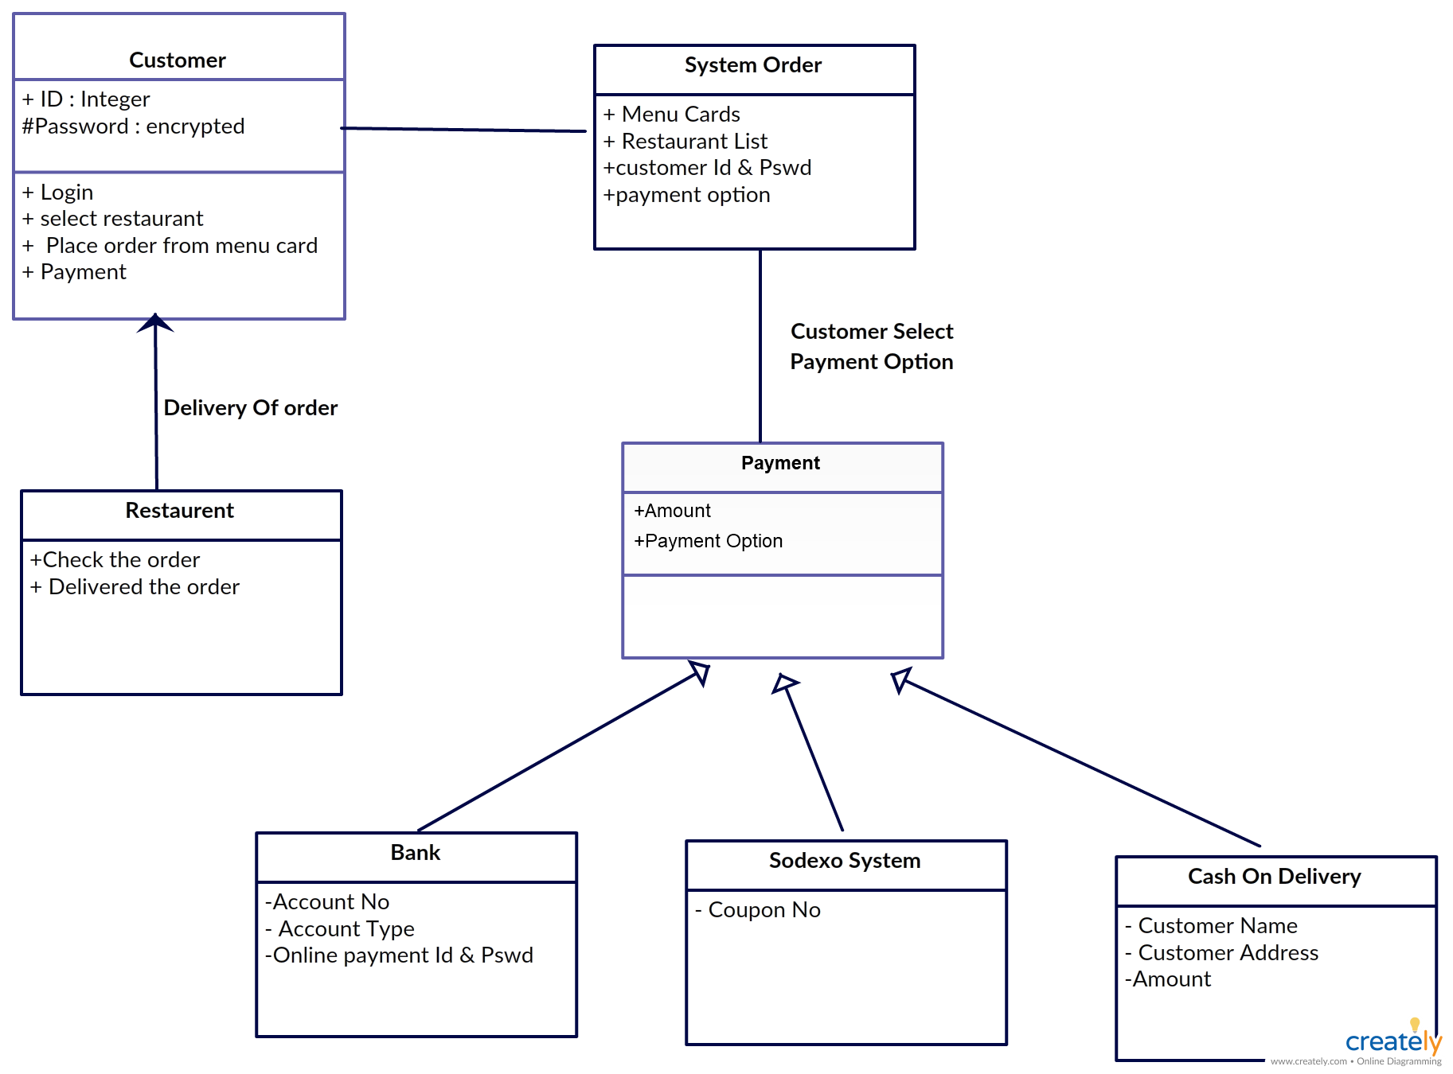

## 3.4 ER Diagram

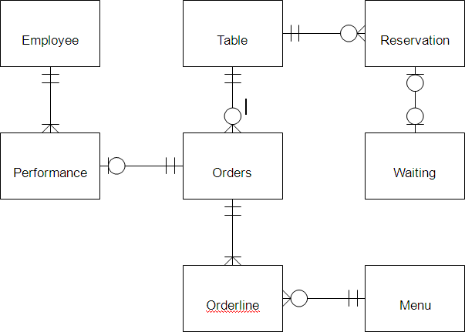

## 3.5 Data Flow Diagram

Customer Management

Gallery

Management

Shopping Management

System User Management

Order

Management

Login

Management

## CHAPTER 4

**SYSTEM CODING**

**4.1 Implementation**

.

### HTML

**Hypertext Markup Language** (**HTML**) is the standard markup language for creating web pages and web applications. With Cascading Style Sheets (CSS) and JavaScript, it forms a triad of cornerstone technologies for the World Wide Web. Web browsers receive HTML documents from a web server or from local storage and render the documents into multimedia web pages. HTML describes the structure of a web page semantically and originally included cues for the appearance of the document.

HTML elements are the building blocks of HTML pages. With HTML constructs, images and other objects such as interactive forms may be embedded into the rendered page. HTML provides a means to create structured documents by denoting structural semantics for text such as headings, paragraphs, lists, links, quotes and other items. HTML elements are delineated by *tags*, written using angle brackets. Tags such<img> and<input> introduce content into the page. Other tags such as <p>..</p>surround and provide information about document text and may include other tags as sub-elements. Browsers do not display the HTML tags, but use them to interpret the content of the page.

**CSS**

CSS Stands for "Cascading Style Sheet." Cascading style sheets are used to format the layout of Web pages. They can be used to define text styles, table sizes, and other aspects of Web pages that previously could only be defined in a page's HTML.

CSS helps Web developers create a uniform look across several pages of a Web site. Instead of defining the style of each table and each block of text within a page's HTML, commonly used styles need to be defined only once in a CSS document. Once the style is defined in cascading style sheet, it can be used by any page that references the CSS file. Plus, CSS makes it easy to change styles across several pages at once. For example, a Web developer may want to increase the default text size from 10pt to 12pt for fifty pages of a Web site. If the pages all reference the same style sheet, the text size only needs to be changed on the style sheet and all the pages will show the larger text.

### Internal Style sheet

First we will explore the internal method. This way you are simply placing the CSS code within the <head></head> tags of each (X)HTML file you want to style with the CSS.In this method each (X)HTML file contains the CSS code needed to style the page. Meaning that any changes you want to make to one page, will have to be made to all. This method can be good if you need to style only one page, or if you want different pages to have varying styles.

### External Style sheet

Next we will explore the external method. An external CSS file can be created with any text or HTML editor such as “Notepad” or “Dreamweaver”. A CSS file contains no (X)HTML, only CSS. You simply save it with the .css file extension. You can link to the file externally by placing one of the following links in the head section of every (X)HTML file you want to style with the CSS file.

**SQL**

SQL stands for Structured Query language. It is a Language to define database objects and manipulate

The data.

**PHP**

PHP stands for Hypertext Preprocessor.PHP is the most widely used open source and general purpose server side scripting Language used mainly in web development to create dynamic websites and applications

**4.1.1 HTML**

<!DOCTYPE html>

<html lang="en">

<head>

<meta charset="UTF-8">

<meta name="viewport"

content="width=device-width, initial-scale=1.0">

<title>Priyanka Spice Factory</title>

<link rel="stylesheet" href="process.css">

</head>

<body>

<header>

<h1 id="top">Online</h1>

<h1 id="top1">FoodShop</h1>

</header>

<hr>

<nav id="navbar">

<img src="./images/gril.jpg">

<ul id="navcontent">

<li><a href="#">Home</a></li>

<li><a href="about.html">About</a></li>

<li><a href="menu.html">Menu</a></li>

<li><a href="link.html">ContactUs</a></li>

</ul>

</nav>

<div id="container1">

<div id="row1">

Welcome to Online FoodShop

</div>

<button class="btn">ORDER NOW</button>

<div id="container3">

<div id="row2">

<button class="btn">Prices</button>

</div>

<div id="row3">

<button class="btn">Specials</button>

</div>

</div>

</div>

<hr>

<h1 id="top3">Featured Products</h1>

<div id="container4">

<div id="row4">

<button class="btn">ORDER NOW</button>

</div>

<div id="row5">

<button class="btn">ORDER NOW</button>

</div>

<div id="row6">

<button class="btn">ORDER NOW</button>

</div>

</div>

<div id="container5">

<div id="row7">

<button class="btn">ORDER NOW</button>

</div>

<div id="row8">

<button class="btn">ORDER NOW</button>

</div>

<div id="row9">

<button class="btn">ORDER NOW</button>

</div>

</div>

<footer>Copyright � 2022-2023 OnlineFoodShop.

All Rights are reserved</footer>

</body>

</html>

<!DOCTYPE html>

<html lang="en">

<head>

<meta charset="UTF-8">

<meta name="viewport" content-"width=device-width, initial-scale=1.0">

<link rel="stylesheet" href="process.css">

<title>About</title>

</head>

<body>

<div Id="About">

<Div Class="About-Wrapper Container">

<Div Class="About-Text">

<H1>About Us</H1>

<H2>We've Beem Making Healthy Food Last For 10 Years</H2>

<P>

<p>My Restaurant was started at 2001,it has a fine reputation.My Restaurant has a large regular clientele.It was fulfill the people exceptation.The food rate is minimum. Some festival season we are offered traditional food also. My restaurant is famous for briyani because my chef cooked briyani really very well. So People frequently order bucket briyani.</p>

<p>

</Div>

<Div Class="About-Img">

<Img Src="./images/res.jpg">

</Div>

</Div>

</div>

</body>

</html

<!DOCTYPE html>

<head>

<meta charset="UTF-8">

<meta name'"viewport" content="width=device-width, initial scale=1.0">

<title>Menu</title>

<link rel="stylesheet" href="process.css">

</head>

<body>

<div Id="Food-Menu">

<H2 Class="Food-Menu-Heading">Food Menu</H2>

<Div Class="Food-Menu-Container Container">

<Div Class="Food-Menu-Item">

<Div Class="Food-Img">

<Img Src= "./images/falafe.jpg">

</Div>

<Div Class="Food-Description">

<H2 Class="Food-Titile">Food Menu Item 1</H2>

<P>

IT is a falafe.IT was cripy potato ball.It is healthy

</P>

<P Class="Food-Price">Price: &#8377; 190</P>

</Div>

</Div>

<Div Class="Food-Menu-Item">

<Div Class="Food-Img">

<Img Src= "./images/masala.jpg">

</Div>

<Div Class="Food-Description">

<H2 Class="Food-Titile">Food Menu Item 2</H2>

<P>

IT is a chinese dish and spicy also. But the taste the out of the world.

</P>

<P Class="Food-Price">Price: &#8377; 250</P>

</Div>

</Div>

<Div Class="Food-Menu-Item">

<Div Class="Food-Img">

<Img Src="./images/tacos al pastor.jpg">

</Div>

<Div Class="Food-Description">

<H2 Class="Food-Titile">Food Menu Item 3</H2>

<P>

It is Tacos al pastor. IT will make on oven and is really crispy.

</P>

<P Class="Food-Price">Price: &#8377; 270</P>

</Div>

</Div>

<Div Class="Food-Menu-Item">

<Div Class="Food-Img">

<Img Src="./images/donar.jpg">

</Div>

<Div Class="Food-Description">

<H2 Class="Food-Titile">Food Menu Item 4</H2>

<P>

IT is a donar. IT was stuffed with some vegtables and it cooked oven

</P>

<P Class="Food-Price">Price: &#8377; 160</P>

</Div>

</Div>

<Div Class="Food-Menu-Item">

<Div Class="Food-Img">

<Img Src="./images/veg.jpg">

</Div>

<Div Class="Food-Description">

<H2 Class="Food-Titile">Food Menu Item 5</H2>

<P>

IT is a sheet pan dinner for winter.IT is good for health and flavorful.

</P>

<P Class="Food-Price">Price: &#8377; 300</P>

</Div>

</Div>

<Div Class="Food-Menu-Item">

<Div Class="Food-Img">

<Img Src="./images/magie.jpg">

</Div>

<Div Class="Food-Description">

<H2 Class="Food-Titile">Food Menu Item 6</H2>

<P>

It is a spit-roasted lamb (doner) kebab, served as a sandwich with vegetables.

</P>

<P Class="Food-Price">Price: &#8377; 150</P>

</Div>

</Div>

</Div>

</div>

</body>

</html>

<!DOCTYPE html>

<head>

<meta charset="UTF-8">

<meta name'"viewport" content="width=device-width, initial scale=1.0">

<title>Menu</title>

<link rel="stylesheet" href="process.css">

</head>

<body>

<div Id="Food-Menu">

<H2 Class="Food-Menu-Heading">Food Menu</H2>

<Div Class="Food-Menu-Container Container">

<Div Class="Food-Menu-Item">

<Div Class="Food-Img">

<Img Src= "./images/falafe.jpg">

</Div>

<Div Class="Food-Description">

<H2 Class="Food-Titile">Food Menu Item 1</H2>

<P>

IT is a falafe.IT was cripy potato ball.It is healthy

</P>

<P Class="Food-Price">Price: &#8377; 190</P>

</Div>

</Div>

<Div Class="Food-Menu-Item">

<Div Class="Food-Img">

<Img Src= "./images/masala.jpg">

</Div>

<Div Class="Food-Description">

<H2 Class="Food-Titile">Food Menu Item 2</H2>

<P>

IT is a chinese dish and spicy also.But the taste the out of the world.

</P>

<P Class="Food-Price">Price: &#8377; 250</P>

</Div>

</Div>

<Div Class="Food-Menu-Item">

<Div Class="Food-Img">

<Img Src="./images/tacos al pastor.jpg">

</Div>

<Div Class="Food-Description">

<H2 Class="Food-Titile">Food Menu Item 3</H2>

<P>

It is Tacos al pastor.IT will make on oven and is really crispy.

</P>

<P Class="Food-Price">Price: &#8377; 270</P>

</Div>

</Div>

<Div Class="Food-Menu-Item">

<Div Class="Food-Img">

<Img Src="./images/donar.jpg">

</Div>

<Div Class="Food-Description">

<H2 Class="Food-Titile">Food Menu Item 4</H2>

<P>

IT is a donar. IT was stuffed with some vegtables and it cooked oven

</P>

<P Class="Food-Price">Price: &#8377; 160</P>

</Div>

</Div>

<Div Class="Food-Menu-Item">

<Div Class="Food-Img">

<Img Src="./images/veg.jpg">

</Div>

<Div Class="Food-Description">

<H2 Class="Food-Titile">Food Menu Item 5</H2>

<P>

IT is a sheet pan dinner for winter.IT is good for health and flavorful.

</P>

<P Class="Food-Price">Price: &#8377; 300</P>

</Div>

</Div>

<Div Class="Food-Menu-Item">

<Div Class="Food-Img">

<Img Src="./images/magie.jpg">

</Div>

<Div Class="Food-Description">

<H2 Class="Food-Titile">Food Menu Item 6</H2>

<P>

It is a spit-roasted lamb (doner) kebab, served as a sandwich with vegetables.

</P>

<P Class="Food-Price">Price: &#8377; 150</P>

</Div>

</Div>

</Div>

</div>

</body>

</html>

<!DOCTYPE html>

<html>

<head>

<title>Login Form</title>

<link rel="stylesheet" href="loginpage.css">

</head>

<body>

<h2>Login Page</h2><br>

<div class="login">

<form id="login" method="post" action="solve.php">

<label><b>User Name

</b>

</label>

<input type="text" name="Uname" id="Uname" placeholder="Username">

<br><br>

<label><b>Password

</b>

</label>

<input type="Password" name="Pass" id="Pass" placeholder="Password">

<br><br>

<input type="button" name="log" id="log" value="Log In Here">

<br><br>

<input type="checkbox" id="check">

<span>Remember me</span>

<br><br>

Forgot <a href="#">Password</a>

</form>

</div>

</body>

</html>

**4.1.2 CSS**

*{

margin:0px;

padding:0px;

}

/*Header Styling*/

#top{

color:rgb(245, 10, 10);

text-align:center;

font-size:46px;

font-family: 'Ubuntu Mono', monospace;

}

#top1{

text-align:center;

color:black;

font-size:21px;

font-family: 'Ubuntu Mono', monospace;

}

/* Navigation bar styling*/

/*Navbar image styling*/

#navbar img{

display:block;

width: 50px;

height:50px;

margin:auto;

margin-bottom: 3px;

}

/*Navbar Functionality*/

#navbar{

display:flex;

flex-direction: column;

background-color: gray;

height: 14vh;

width: 100vw;

font-family: 'Ubuntu Mono', monospace;

margin-top:10px;

border: 2px solid black;

border-radius:15px;

}

/*Navbar content functionality*/

#navcontent{

display: flex;

justify-content: center;

}

/*Navbar content styling*/

ul li{

list-style: none;

margin: 15px;

border-radius: 20px;

}

ul li a{

padding: 1px;

color:white;

text-decoration: none;

border-radius:10px;

}

ul li a:hover{

background-color: blue;

border-radius: 10px;

}

/* website background image designing */

#container1{

position: relative;

display: flex;

flex-direction: column;

align-items: center;

width: 100vw;

height:63vh;

}

/*Setting the background image using before pseudo selector*/

#container1::before{

content:'';

background: url('./images/receipe.jpg') no-repeat center center/cover;

width: 100vw;

height:59vh;

position: absolute;

top:0px;

left: 0px;

font-family: 'Ubuntu Mono', monospace;

margin-right:45px;

font-weight: bold;

z-index: -1;

opacity: 0.89;

border: 2px solid black;

border-bottom-left-radius: 100px;

}

#row1{

color: blue;

font-weight:bold;

font-size: 3rem;

text-align: center;

margin-top: 35px;

}

/*Button Styling*/

.btn{

margin-top:15px;

border: 3px solid white;

border-radius:15px;

background-color:yellow;

font-size:20px;

font-weight: bold;

font-family: 'Ubuntu Mono', monospace;

}

.btn:hover{

cursor: pointer;

background-color: red;

}

#container3{

display: flex;

justify-content: space-evenly;

}

#row2{

width:24vw;

height:21vh;

box-shadow: 2px 7px 16px 19px;

margin-top:51px;

margin-bottom: 51px;

display: flex;

justify-content: center;

align-items: flex-end;

position: relative;

margin-right: 38px;

border-radius: 40px;

}

#row2::before{

content: '';

background: url('./images/chef.jpg') no-repeat center center/cover;

position: absolute;

top: 0px;

left:0px;

width: 24vw;

height:21vh;

z-index: -1;

border-radius: 40px;

}

#row3{

position: relative;

width: 24vw;

height:21vh;

display: flex;

justify-content: center;

align-items: flex-end;

box-shadow: 2px 7px 16px 19px;

margin-top:51px;

margin-bottom: 51px;

margin-left: 38px;

border-radius: 40px;

}

#row3::before{

content: '';

background: url('./images/pizza.jpg') no-repeat center center/cover;

position: absolute;

top:0px;

left:0px;

width: 24vw;

height:21vh;

z-index: -1;

border-radius: 40px;

}

#top3{

text-align: center;

color:red;

font-family: 'Ubuntu Mono', monospace;

}

#container4{

display: grid;

grid-template-columns: repeat(auto-fit, minmax(350px, 1fr));

margin: 41px;

}

#row4{

width: 29vw;

height: 360px;

border: 2px solid black;

background:url('./images/burger.jpg') no-repeat center center/cover;

display: flex;

justify-content:center;

align-items:flex-end;

border-radius: 15px;

}

#row5{

width: 29vw;

height: 360px;

border: 2px solid black;

background:url('./images/Chicken-Drumsticks-Recipe.jpg') no-repeat center center/cover;

display: flex;

justify-content:center;

align-items:flex-end;

border-radius: 15px;

}

#row6{

width: 30vw;

height: 360px;

border: 2px solid black;

background:url('./images/noodle.jpg') no-repeat center center/cover;

display: flex;

justify-content:center;

align-items:flex-end;

border-radius: 15px;

}

#container5{

display: grid;

grid-template-columns: repeat(auto-fit, minmax(350px, 1fr));

margin: 41px;

}

#row7{

width: 29vw;

height: 360px;

border: 2px solid black;

background:url('./images/fish.jpg') no-repeat center center/cover;

display: flex;

justify-content:center;

align-items:flex-end;

border-radius: 15px;

}

#row8{

width: 29vw;

height: 360px;

border: 2px solid black;

background:url('./images/fulmeal.jpg') no-repeat center center/cover;

display: flex;

justify-content:center;

align-items:flex-end;

border-radius: 15px;

}

#row9{

width: 30vw;

height: 360px;

border: 2px solid black;

background:url('./images/kids.jpg') no-repeat center center/cover;

display: flex;

justify-content:center;

align-items:flex-end;

border-radius: 15px;

}

/*Designing the footer*/

footer{

text-align: center;

}

/*Designing of Contact Us*/

#ContactUs{

width:100vw;

height:100vh;

display:flex;

flex-direction: column;

align-items: center;

background-color: gray;

}

.form-shape input, .form-shape select, .form-shape textarea{

width: 92%;

padding: 0.5rem;

}

/*Changing the color of placeholder*/

::placeholder{

color:gray;

}

#About {

Padding: 50px 0;

Background: #F5f5f7

}

.About-Wrapper {

Display: Flex;

Flex-Wrap: Wrap;

}

#About H1 {

margin-bottom:64px;

Font-Size: 2.3rem;

Text-align:center;

color:blue;

}

#About H2 {

Font-Size: 2.3rem;

}

#About P {

Font-Size: 1.2rem;

Color: #555;

}

.About-Img {

Flex: 1 1 400px;

Padding: 30px;

Transform: TranslateX(150%);

Animation: About-Img-Animation 1s Ease-In-Out Forwards;

}

@Keyframes About-Img-Animation {

100% {

Transform: Translate(0);

}

}

.About-Text {

Flex: 1 1 400px;

Padding: 30px;

Margin: Auto;

Transform: Translate(-150%);

Animation: About-Text-Animation 1s Ease-In-Out Forwards;

}

@Keyframes About-Text-Animation {

100% {

Transform: Translate(0);

}

}

.About-Img Img {

Display: Block;

Height: 400px;

Max-Width: 100%;

Margin: Auto;

Object-Fit: Cover;

Object-Position: Right;

}

.Food-Menu-Heading {

Text-Align: Center;

Font-Size: 3.4rem;

Font-Weight: 400;

Color: #666;

}

.Food-Menu-Container {

Display: Flex;

Flex-Wrap: Wrap;

Padding: 50px 0px 30px 0px;

}

.Food-Menu-Container Img {

Display: Block;

Width: 250px;

Height: 250px;

Border-Radius: 50%;

Object-Fit: Cover;

Object-Position: Center;

}

.Food-Menu-Item {

Display: Flex;

Flex: 1 1 600px;

Justify-Content: Space-Evenly;

Margin-Bottom: 3rem;

}

.Food-Description {

Margin: Auto 1.5rem;

}

.Font-Title {

Font-Size: 1.8rem;

Font-Weight: 400;

Color: #444;

}

.Food-Description P {

Font-Size: 1.4rem;

Color: #555;

Font-Weight: 500;

}

.Food-Description .Food-Price {

Color: #117964;

Font-Weight: 700;

}

/*Making the webpage responsive using media queries*/

@media only screen and (max-width:1131px){

#row4{

Width: 42vw;

}

#row5{

width:45vw;

}

#row6{

margin-top: 20px;

width:90vw;

}

#row7{

width: 42vw;

}

#row8{

width:45vw;

}

#row9{

margin-top: 20px;

width:90vw;

}

}

@media only screen and (min-width:600px) and (max-width:781px)

{

#row4{

width:84vw;

margin: auto;

margin-left: 22px;

}

#row5{

width:84vw;

margin: auto;

margin-top: 20px;

margin-left: 22px;

}

#row6{

width:84vw;

margin: auto;

margin-top: 20px;

margin-left: 22px;

}

#row7{

width:84vw;

margin: auto;

margin-left: 22px;

}

#row8{

width:84vw;

margin: auto;

margin-top: 20px;

margin-left: 22px;

}

#row9{

width:84vw;

margin: auto;

margin-top: 20px;

margin-left: 22px;

}

}

@media only screen and (max-width:600px){

#row4{

width:78vw;

margin: auto;

margin-left: 3px;

}

#row5{

width:78vw;

margin: auto;

margin-top: 20px;

margin-left: 3px;

}

#row6{

width:78vw;

margin: auto;

margin-top: 20px;

margin-left: 3px;

}

#row7{

width:78vw;

margin: auto;

margin-left: 3px;

}

#row8{

width:78vw;

margin: auto;

margin-top: 20px;

margin-left: 3px;

}

#row9{

width:78vw;

margin: auto;

margin-top: 20px;

margin-left: 3px;

}

}

@media only screen and (min-height:1000px){

#navbar{

height:10vh;

}

#container1::before{

height:39vh;

}

#container1{

height:44vh

}

}

/*Login Form*/

body

{

margin: 0;

padding: 0;

background-color:#6abadeba;

font-family: 'Arial';

}

.login{

width: 382px;

overflow: hidden;

margin: auto;

margin: 20 0 0 450px;

padding: 80px;

background: #23463f;

Border-radius: 15px ;

}

h2{

text-align: center;

color: #277582;

padding: 20px;

}

label{

color: #08ffd1;

font-size: 17px;

}

#Uname{

width: 300px;

height: 30px; s

border: none;

border-radius: 3px;

padding-left: 8px;

}

#Pass{

Width: 300px;

height: 30px;

border: none;

border-radius: 3px;

padding-left: 8px;

}

#log {

Width: 300px;

Height: 30px;

border: none;

Border-radius: 17px;

Padding-left: 7px;

color: blue;

}

span{

color: white;

Font-size: 17px;

}

a{

float: right;

background-color: grey;

}

**4,3.3 Database**

<?php>

$server="localhost";

$username="root";

$password="";

$dbname="contactus";

$con = mysqli_connect($server, $username, $password, $dbname);

if(!$con)

{

echo "not connected";

}

$name=$_POST['myName'];

$email=$_POST['myEmail'];

$phoneno=$_POST['myPhone'];

$elaborate your query=$_POST['mesg'];

$sql = "INSERT INTO `contact`(`name`, `email`, `phone no`, `elaborate your query`) VALUES ('$name','$email','$phoneno','$elaborate your query')";

$result = mysqli_query($con , $sql);

if($result)

{

echo "data submitted";

}

else

{

echo "query failed.....!";

}

?>

**4.2 SCREENSHOTS**

**Fig 4.2.1.Database Connectivity**

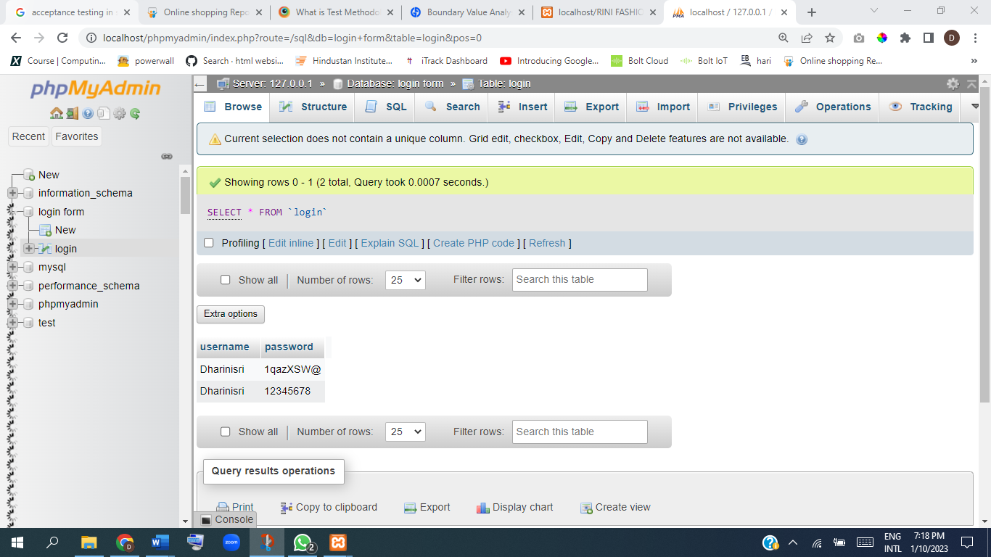

**Fig 4.2.2.Opening the Home page**

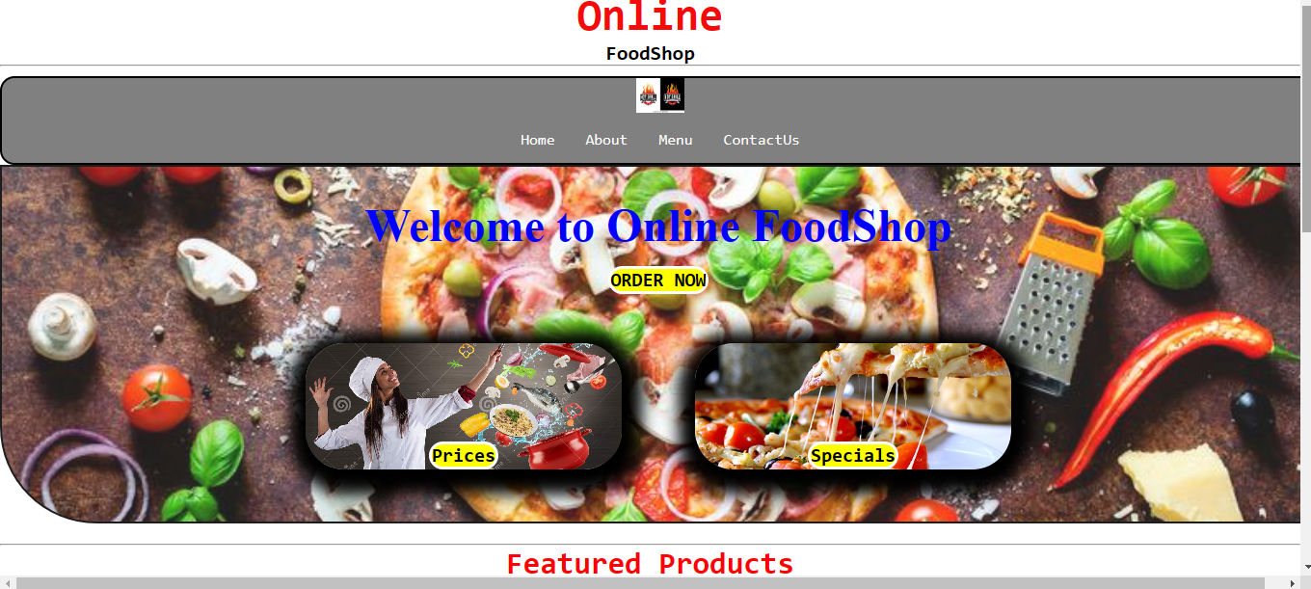

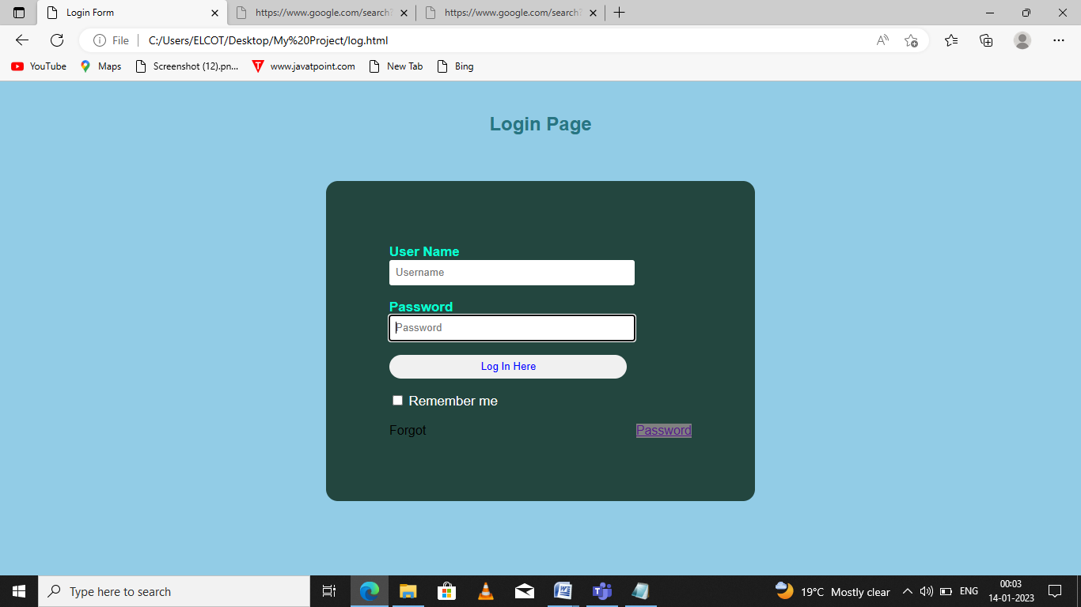**Fig: 4.2.3 Login page**

**Fig:4.1.4 About Page**

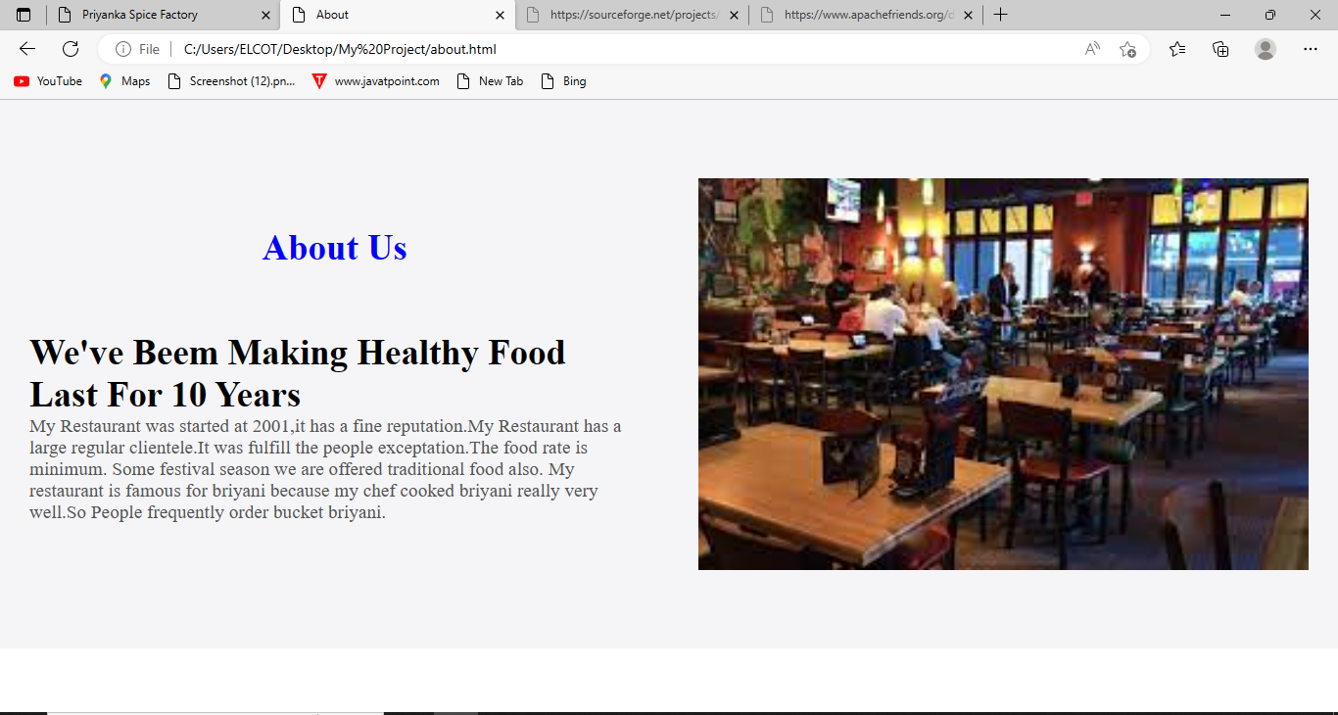

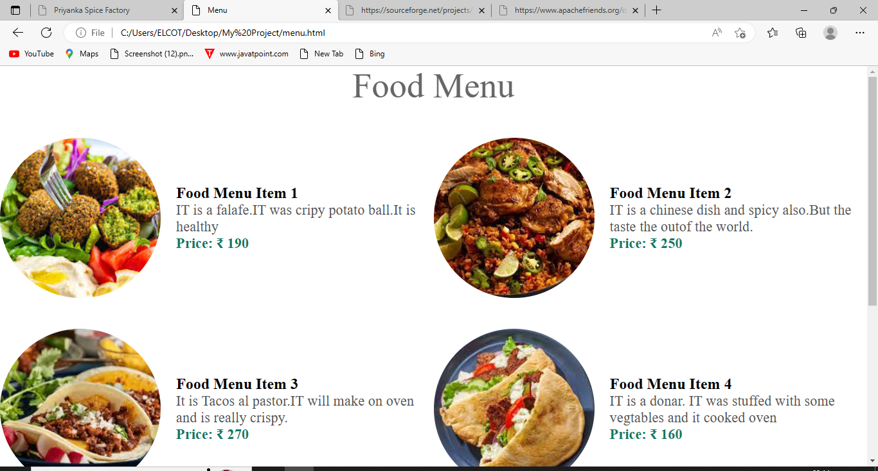**Fig 4.1.5. Food Menu page**

## Fig: 4.1.6. Contact Page

## Screenshot (12).png

**CHAPTER 5**

**SYSTEM TESTING**

**5.1 Software Testing**

Software testing is an activity to check whether the actual results match the expected results and to ensure that the software system is Defect free. It involves execution of a software component or system component to evaluate one or more properties of interest.Software testing also helps to identify errors, gaps or missing requirements in contrary to the actual requirements. It can be either done manually or using automated tools. Some prefer saying Software testing as a white box and Black Box Testing.

### 5.2 Software Testing Life Cycle (STLC)

Software Testing Life Cycle (STLC) is defined as a sequence of activities conducted to perform Software Testing .It consists of series of activities carried out methodologically to help certify your software product.

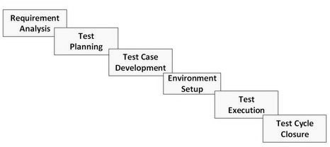

Software testing is the process of executing a program with intension of finding errors in the code. It is a process of evolution of system or its parts by manual or automatic means to verify that it is satisfying specified or requirements or not. Generally, no system is perfect due to communication problems between user and developer, time constraints, or conceptual mistakes by developer. To purpose of system testing is to check and find out these errors or faults as early as possible so losses due to it can be saved.

Testing is the fundamental process of software success. Testing is not a distinct phase in system development life cycle but should be applicable throughout all phases i.e. design development and maintenance phase. Testing is used to show incorrectness and considered to success when an error is detected.

### 5.3 Objective of Software Testing

The software testing is usually performed for the following objectives

### 5.3.1 Software Quality Improvement

The computer and the software are mainly used for complex and critical applications and a bug or fault in software causes severe losses. So a great consideration is required for checking for quality of software.

### 5.3.2 Verification and Validation

Verification means to test that we are building the product in right way .i.e. are we using the correct procedure for the development of software so that it can meet the user requirements.

Validation means to check whether we are building the right product or not.

### 5.3.3 Software Reliability Estimation

The objective is to discover the residual designing errors before delivery to the customer. The failure data during process are taken down in order to estimate the software reliability.

### 5.4 Principles of Software Tesing

Software testing is an extremely creative and challenging task. Some important principles of software testing are as given:-

* + All tests should be traceable to customer requirements.
  + Testing time and resources should be limited i.e. avoid redundant testing.
  + It is impossible to test everything.
  + For the most effective testing should be conducted by an independent party.
  + Document test cases and test results.
  + Examining what the software not doing which it expected to do and also checking what it is doing that was not expected to do.

### 5.5 Strategy for Software Testing

##### **Different levels of testing are used in the test process; each level of testing aims to test different aspects of the system.**

The First Level is **unit testing**. In this testing, individual components are tested to ensure that they operate correctly. It focuses on verification efforts .The Second Level is **integration testing**. It is a systematic technique for constructing the

program structure. In this testing, many tested modules are combined into the subsystems which are then tested. The good here is to see if the modules can be integrated properly.

The Third Level is **system testing**: System testing is actually a series of different tests whose primary purpose is to fully exercise computer based system.

### 5,.6 Software Testing Methodologies

5.6.1.**Waterfall Model**

The first phase in the waterfall model is the requirements phase in which all the project requirements are completely defined before starting the testing. During this phase, the test team brainstorms the scope of testing, test strategy and drafts a detailed test plan.

Only once the design of software is complete, the team will move on to execution of the test cases to ensure that the developed software behaves as it expected.

**Advantages**

This software Engineering model is very simple to plan and manage. Hence, projects, where requirements are clearly defined and stated beforehand, can be easily tested using a waterfall model.

**Disadvantages**

In the waterfall model, you can begin with the next phase only once the previous phase is completed. Hence, this model cannot accommodate unplanned events and uncertainty.

This methodology is not suitable for projects where the requirements change frequently.

## 5.6.2 Iterative development

As soon as iteration is completed, the entire system is subjected to testing. Feedback from testing is immediately available and is incorporated in the next cycle. The testing time required in successive iteration can be reduced based on the experience gained from past iterations.

**Advantages**

The main advantage of iterative development is the test feedback is immediately available at the end of each cycle.

**Disadvantages**

This model increases communication overheads significantly since, at the end of each cycle, feedback about deliverables, effort etc must be given.

## 5.6.3 Agile methodology

incremental testing is used in agile development methods and hence, every release of the project is tested thoroughly. This ensures that any bugs in the system are fixed before the next release.

**Advantages**

It is possible to make changes in the project at any time to comply with the requirements.

This incremental testing minimizes risks.

**Disadvantages**

Constant client interaction means added time pressure on all stakeholders including the client themselves, software development and test teams.

## 5.6.4 Extreme programming

Extreme programming follows a Test-driven development which is described as follows –

1. Add ato test case the test suite  to verify the new functionality which is yet to be developed
2. Run all the tests and obviously the new test case added must fail since the functionality is not coded yet
3. Write some code to implement the feature/functionality
4. Run the test suite again. This time, the new test case should pass since the functionally has been coded

**Advantages**

Customers having a  vague software design in mind could use extreme programming

1. Continuous testing and continuous integration of small releases ensure software code is delivered is of high quality

# 5.7 Equivalence Partitioning Method

**Equivalence Partitioning Method** is also known as Equivalence class partitioning (ECP). It is a software testing  technique or black-box testing that divides input domain into classes of data, and with the help of these classes of data, test cases can be derived. An ideal test case identifies class of error that might require many arbitrary test **cases** to be executed before general error is observed. In equivalence partitioning, equivalence classes are evaluated for given input conditions. Whenever any input is given, then type of input condition is checked, then for this input conditions, Equivalence class represents or describes set of valid or invalid states.

**Guidelines for Equivalence Partitioning :**

* If the range condition is given as an input, then one valid and two invalid equivalence classes are defined.
* If a specific value is given as input, then one valid and two invalid equivalence classes are defined.
* If a member of set is given as an input, then one valid and one invalid equivalence class is defined.
* If Boolean no. is given as an input condition, then one valid and one invalid equivalence class is defined.
* **Example-1:**   
  Let us consider an example of any college admission process. There is a college that gives admissions to students based upon their percentage.
* Consider percentage field that will accept percentage only between 50 to 90 %, more and even less than not be accepted, and application will redirect user to an error page. If percentage entered by user is less than 50 %or more than 90 %, that equivalence partitioning method will show an invalid percentage. If percentage entered is between 50 to 90 %, then equivalence partitioning method will show valid percentage.
* 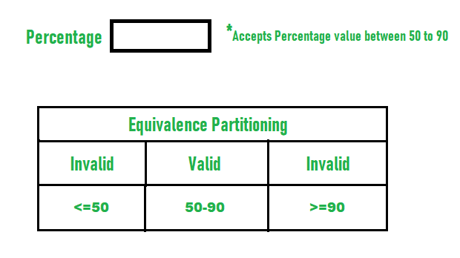

**5.8 Boundary value Analysis**

Boundary testing is the process of testing between extreme ends or boundaries between partitions of the input values.

* So these extreme ends like Start- End, Lower- Upper, Maximum-Minimum, Just Inside-Just Outside values are called boundary values and the testing is called “boundary testing”.
* The basic idea in normal boundary value testing is to select input variable values at their:

1. Minimum
2. Just above the minimum
3. A nominal value
4. Just below the maximum
5. Maximum

* In Boundary Testing, Equivalence Class Partitioning plays a good role
* Boundary Testing comes after the Equivalence Class Partitioning.

**5.9 Test Reports**

**5.9.1 Test cas e Report**

* Test cases are divided into functional and nonfunctional category it will be described in a separate column.
* Test cases are assorted for all modules of **Priyanka Spice Factory** so as to have a complete code module coverage.
* Every cycle of testing can create this table and add date as per reference**.**

|  |  |
| --- | --- |
| Project name | Priyanka Spice Factory |
| Reference | C:Users\Elcot\Desktop\project\learn.html |
| Created By | Priyanka P |
| On Date | 02.01.2023 |

Test Scenario: 01 Login

|  |  |  |  |  |  |  |
| --- | --- | --- | --- | --- | --- | --- |
| Test Case id | Test Objective | Precondition | Steps | Test data | Except Result | Actual Output |
| TC Am 01 | Successful sign in option | A Valid user Account only sign in | 1.Give the username  2.Gie the password  3. click on sign in option | A valid username  A valid password | User sign in successfully | Pass |
| TC Am 2 | Successful sign in option | A Valid user Account only sign in | 1.Give the username  2.Gie the password  3. click on sign in option | A valid username  A invalid password | User is not sign in | Fail |
| TC Am 3 | Successful sign in option | A Valid user Account only sign in | .Give the username  2.Gie the password  3. click on sign in option | A invalid username  A valid password | User is not sign in | Fail |
| TC Am 4 | Successful sign in option | A Valid user Account only sign in | A Valid user Account only sign in | A invalid username  A invalid password | User is not sign in | Fail |
| TC Am 5 | Forgot password | A valid mobile number and email only sign in | 1.Give the valid number and password  2.Click the forget password  3.Give the new password | The valid mobile or email only sign in | User is sign in successfully | Pass |
| TC Am 6 | Forgot password | A valid mobile number and email only sign in | 1.Give the valid number and password  2.Click the forget password  3.Give the new password with character | The invalid mobile number and password | The user is not sign in | Fail |

**Test Scenario: 02 Menu Details**

|  |  |  |  |  |  |  |  |  |
| --- | --- | --- | --- | --- | --- | --- | --- | --- |
| Test Case ID | Test  Case  Name | Steps | Pre  Condition | Input | Actual | Expected | Post  Condition | Result |
| TC Am 06 | Add  Menu | 1.Internet Connectivity  2.User must have account | User able to select the multiple  menu | Check the valid  menu | 10  Menu  Details | As  Expected | Menu details are displayed | Pass |
| Tc Am 07 | Add  Menu | 1.Internet  Connectivity  2.User must have account | User not able to select the multiple menu | Check the invalid product | 10  Menu details not display | As  Expected | Menu details are not  displayed | Fail |

**Test Scenario: 03 Manage & Update**

|  |  |  |  |  |  |  |  |  |
| --- | --- | --- | --- | --- | --- | --- | --- | --- |
| Test Case ID | Test  Case  name | Steps | Pre  Condition | Input | Actual | Expected | Post  Condition | Result |
| TC Am 007 | Update and valid details | 1.Internet  Connectivity  2.User must have account  User details should properly check | User details able to add properly | Check the valid details | Number of details should added | As Expected | Menu Details page displayed | Pass |
| TC AM 008 | Update and valid details | 1.Internet  Connectivity  2.User must have account  User details should properly check | User details are not able to add properly | Check the  Invalid details | Number of details should not added | As Expected | Menu Details page not displayed | Fail |

**5.9.2 Automated selenium of Priyanka Spice Factory**

* As the system is scalable, more modules can be added as when required.
* The database that is used in the system can be connected to the any online examination.
* It can be browser independent so that the sitecan browser.
* The System contents can be modified to accept new attributes for any criterion.

**Selenium Code:**

**package** seleniumproject;

**import** org.openqa.selenium.By;

**import** org.openqa.selenium.WebDriver;

**import** org.openqa.selenium.chrome.ChromeDriver;

**import** org.openqa.selenium.support.ui.Select;

**public** **class** Web {

**public** **static** **void** main(String[] args) **throws** InterruptedException {

System.*setProperty*("webdriver.chrome.driver", "C:\\Users\\ELCOT\\AppData\\Local\\Temp\\Temp1_ChromeDriver_win32.zip\\chromedriver.exe");

WebDriver driver=**new** ChromeDriver();

driver.get ("file:///C:/Users/ELCOT/Desktop/My%20Project/learn.html");

String n=driver.getTitle();

System.***out***.println ("the title og the web page" +n);

String Url=driver.getCurrentUrl ();

System.***out***.println("The link of the website is" +Url);

// Contact Us

driver.findElement(By.*xpath*("//a[@href='link.html']")).click();

Select query=**new** Select(driver.findElement(By.*id*("query")));

query.selectByVisibleText("Order related Issues");

query.selectByIndex (2);

driver.findElement(By.*id*("name")).sendKeys("Priyanka");

driver.findElement (By.*id*("email")).sendKeys("priyavadivu01@gmail.com");

driver.findElement(By.*id*("pho")).sendKeys("6382913097");

driver.findElement(By.*id*("yes radio")).click();

driver.findElement(By.*id*("message")).sendKeys("Did the menu have a good variety of item?");

driver.findElement(By.*id*("range")).click();

//

driver.get("file:///C:/Users/ELCOT/Desktop/My%20Project/about.html");

driver.findElement(By.*xpath*("//a[@href='about.html']")).click();

Thread.*sleep*(5000);

driver.quit();

}

}

**5.9.3 SCREEN SHOTS:**

**Fig: 5.9.3.(1) Launch Priyanka Spice Factory**

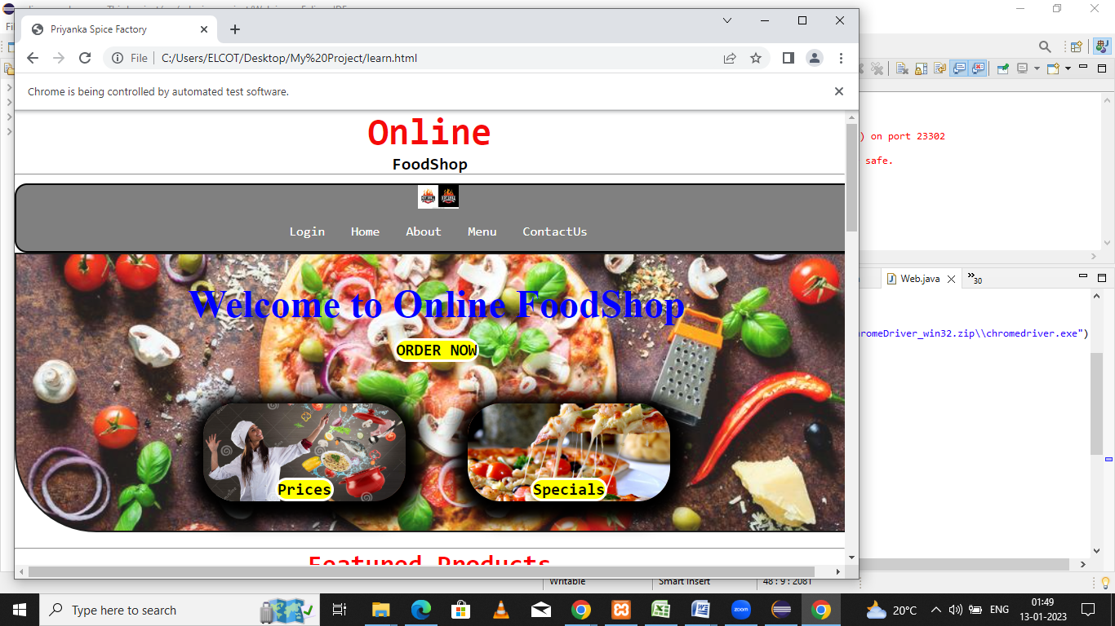

I am doing the Automation selenium in my front end design the home page is open.

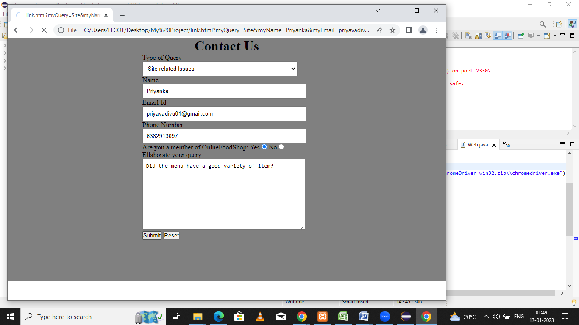

**Fig 5.9.3(2) Opening the Contact US page**

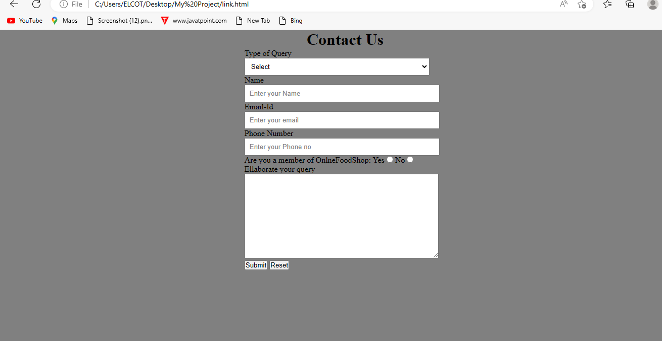

I am inspect the contact US page. It will open the page.

**Fig 5.9.3(3) Sending Key Values to the Contact Us page**

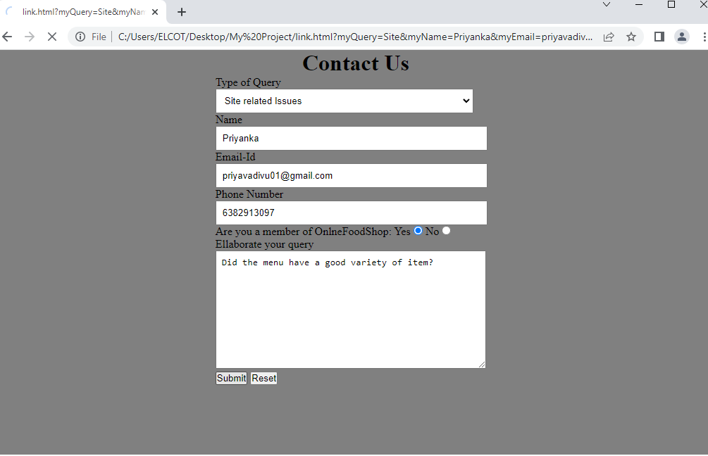

I am inspecting the all the box and I sending the values. Then the values are automatically sending to the box

**Fig 5.9.4(4) Opening the About page**

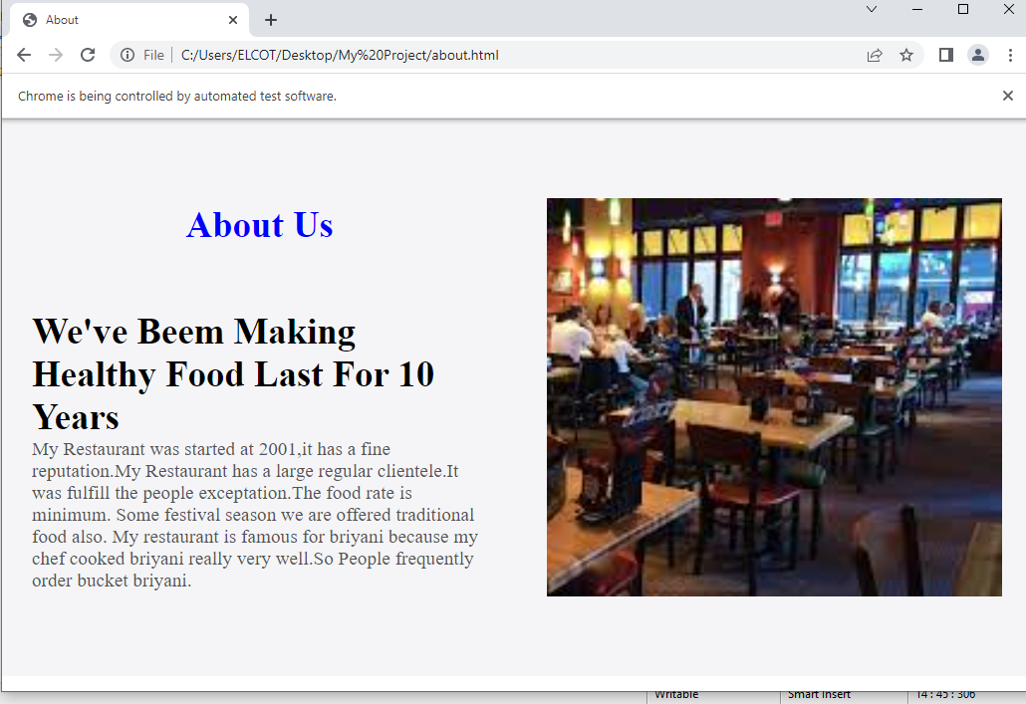

I am inspecting the about page and I doing the automation testing. Then the page will open

**5.9.4 Done Automation Selenium of Amazon**

package selenium project;

import org.openqa.selenium.By;

import org.openqa.selenium.WebDriver;

import org.openqa.selenium.chrome.ChromeDriver;

public class Problem {

public static void main(String[] args) {

System.*setProperty*("webdriver.chrome.driver", "C:\\Users\\ELCOT\\eclipse-workspace\\cumcum\\src\\test\\resources\\driverschrome\\chromedriver.exe");

WebDriver driver=new ChromeDriver();

driver.get("http://www.amazon.in/");

String n=driver.getTitle();

System.***out***.println("the title of the web page" +n);

String Url=driver.getCurrentUrl();

System.***out***.println("the web page is"+Url); sign in

driver.findElement(By.*cssSelector*("span[id='nav-link-accountList-nav-line-1']")).click();

driver.findElement(By.*id*("ap_email")).sendKeys("6382913097");

driver.findElement(By.*id*("continue")).click();

driver.findElement(By.*id*("ap_password")).sendKeys("Priya@2001");

driver.findElement(By.*cssSelector*("span[class='a-label a-checkbox-label']")).click();

driver.findElement(By.*id*("signInSubmit")).click();

//search bar

driver.findElement(By.*id*("twotabsearchtextbox")).sendKeys("phone");

driver.findElement(By.*id*("nav-search-sumbit-button")).click();

System.***out***.println("successfull done the search for option");

}

}

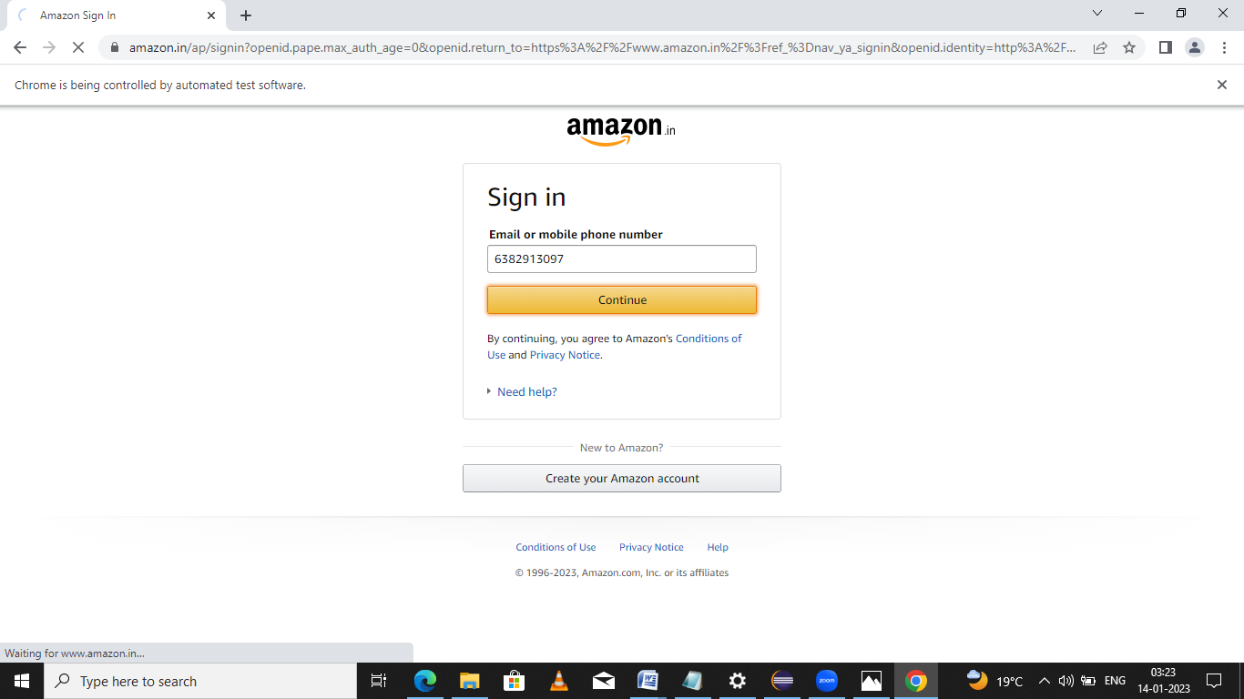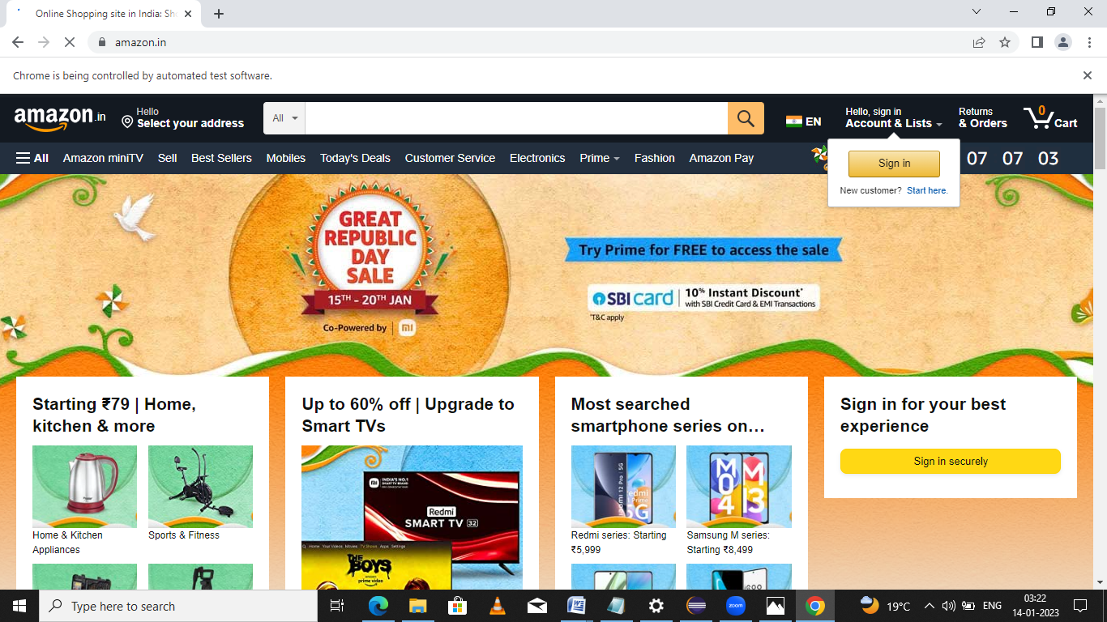**5.9.4(1) Amazon page is opening**

**5.9.4(2)Sign in page opening**

**5.9.4(3) successful Sign in**

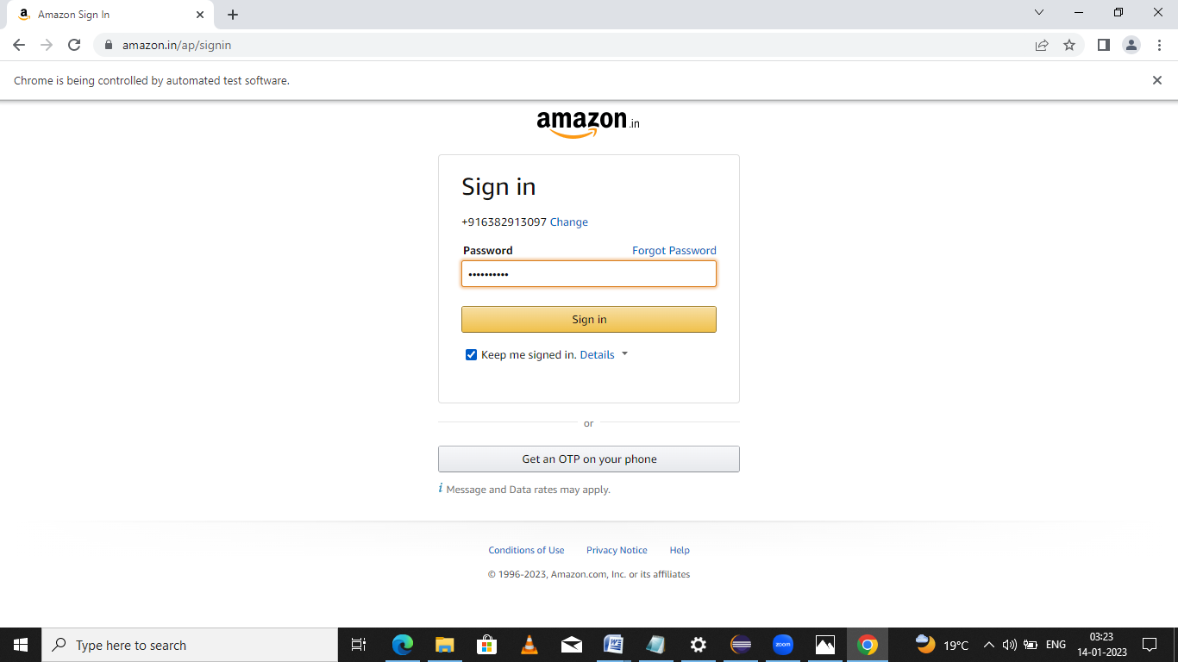

**5.9.4(4) Using the Search option**

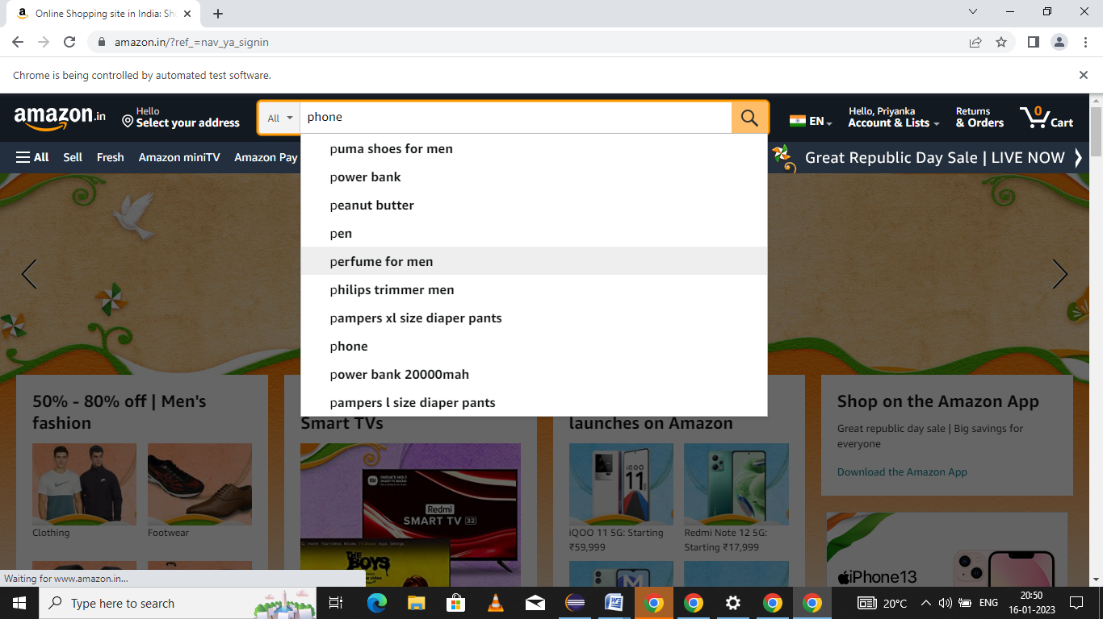

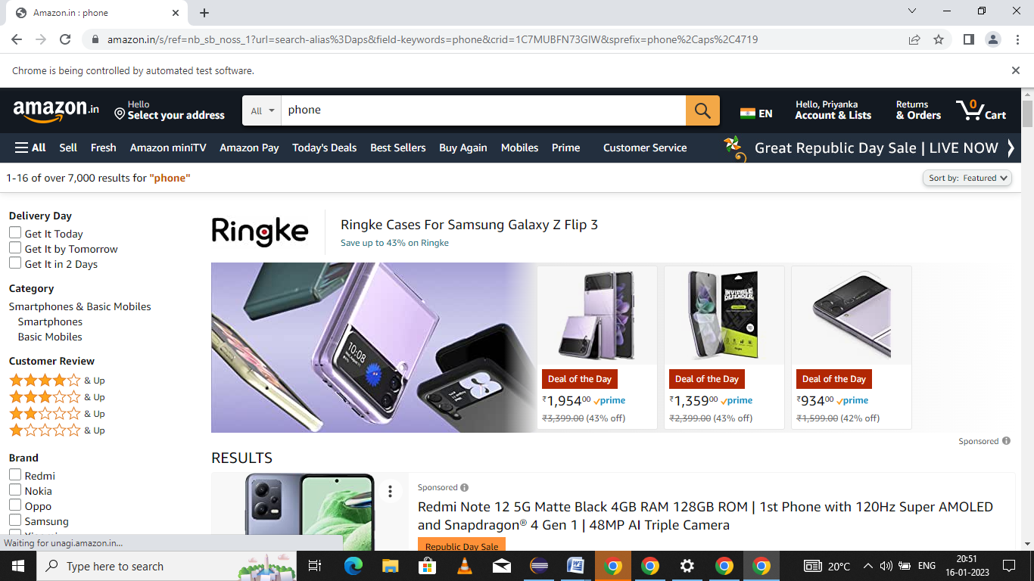**5.9.4(5) Getting the template**

**5.9.5 Done the Automation testing of Cucumber**:

package steps definition;

import org.openqa.selenium.By;

import org.openqa.selenium.Keys;

import org.openqa.selenium.WebDriver;

import org.openqa.selenium.chrome.ChromeDriver;

import io.cucumber.java.en.And;

import io.cucumber.java.en.Given;

import io.cucumber.java.en.Then;

import io.cucumber.java.en.When;

public class Login step {

WebDriver driver=null;

@Given("user is on google search page")

public void user_is_on_login_page() {

System.***out***.println("user is on google search page”);

String project path=System.*getProperty*("user.dir");

System.***out***.println("Project path is:"+projectpath);

System.*setProperty*("webdriver.chrome.driver", projectpath+ "\\src\\test\\resources\\driverschrome\\chromedriver.exe");

driver=new ChromeDriver();

driver.navigate().to("https://google.com");

}

@When("user enters a text in box")

public void user_is_on_google_search_page() {

driver.findElement(By.*name*("q")).sendKeys("Automation step by step");

}

@And("hits enter")

public void hits_enter() {

driver.findElement(By.*name*("q")).sendKeys(Keys.ENTER);

}

@Then("user is navigated to the search results.")

public void user_is_navigated_to_the_search_results() {

driver.getPageSource().contains("online course");

driver.close();

driver.quit();

}

}

Features of Cucumber

Feature: feature to test google functionality

Scenario: valid google search is working

Given user is on google search page

When user enters a text in box

And hits enter

Then user is navigated to the search results.

**5.10 SCREENSHOTS:**

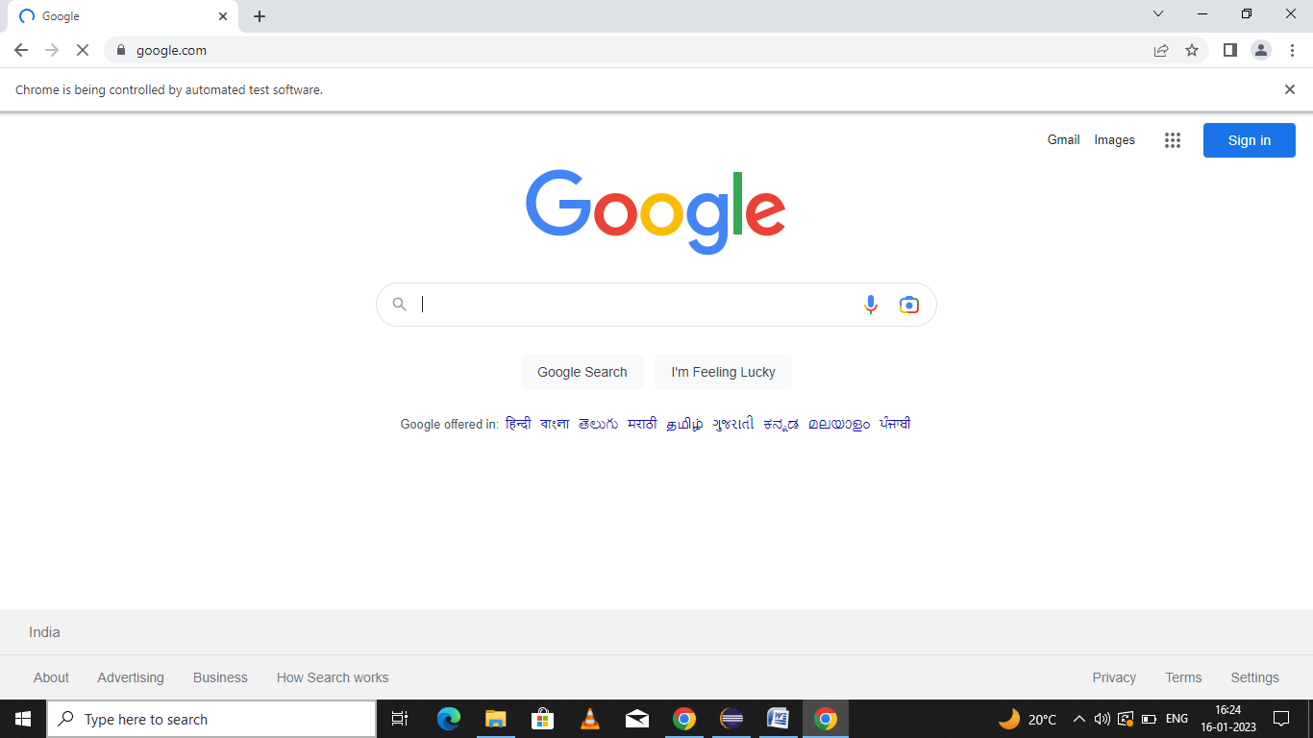**5.10.1Opening the Google page**

**5.10.2 Using the Checkbox**

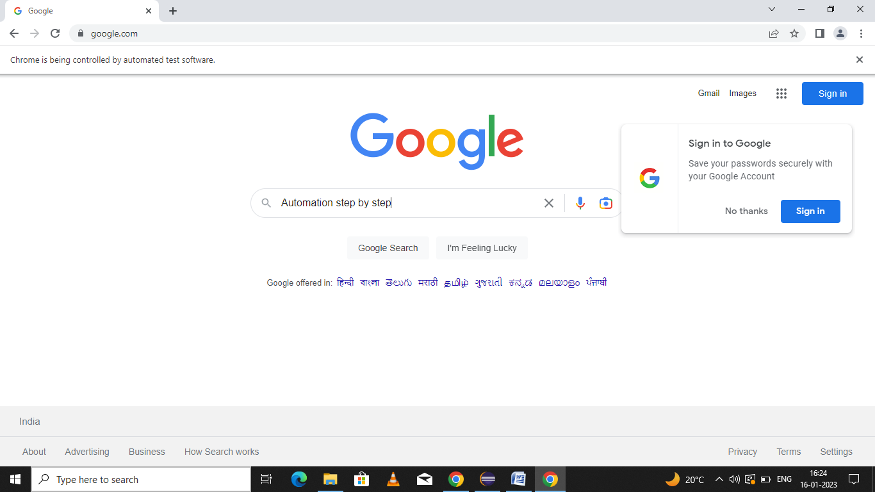

**5.10.3 Going to the value**

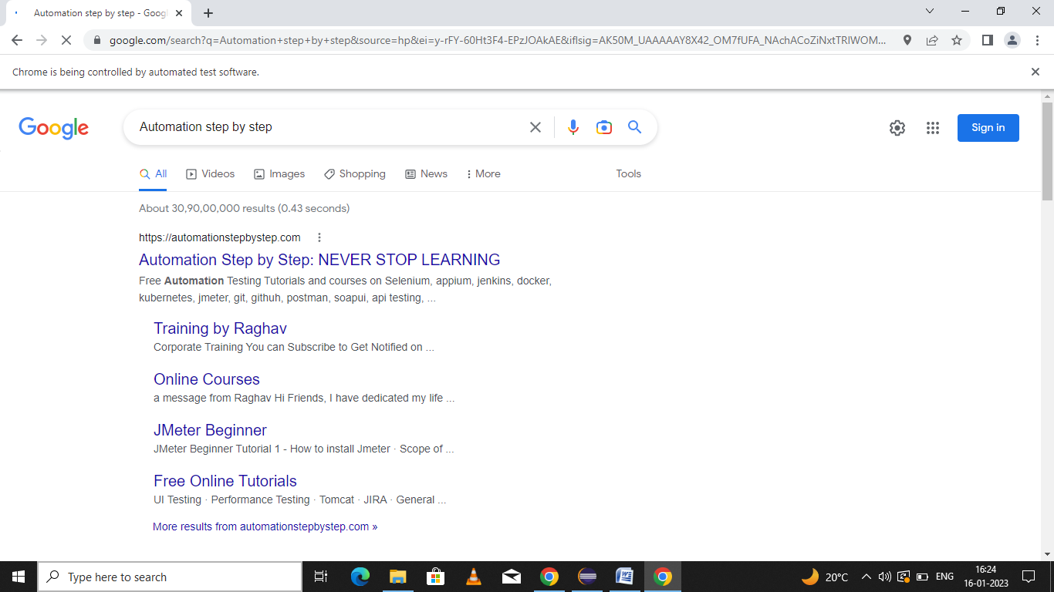

**CHAPTER 6**

**CONCLUSION**

Developing a Project Priyanka Spice Factory is never easy task during the process of creating the database we have learned so many things like taking the real words objects into considerations and creating the entities and attributes, normalizing the entire schema and analyzing the functional dependencies and the most crucial part is to retrieving the data.

The project has been appreciated by all the users in the organization. IT is easy to uses the GUI provided. The User friendly screens are provided. The usage of software increase the efficiency, decrease the effort. IT has been efficiently employed as a site management mechanism. It has been thoroughly tested a been implemented.

In conclusion for every front-end application we develop there should be a concrete database model to represent the application. In our case